Conservation Planning Support System Oriented Programming
Software Architecture Documentation

Table of Contents
1. Introduction 4
1.1 Purpose 4
2. project Goals 5
3. Architectural Representation 5
3.1 usecase diagram 5
3.2 class diagram, 6
4. Working of system 8

5. conclusion 10

Tourism Management Application

Introduction
This IDE based java application is about tourism management. Which will help tourist or user to access
information and navigate various places in Kyoto. users will be able to find useful data about best place for shopping, best restaurants city and country wise etc. Hence they would be able to make best decision for better holiday experience.

Purpose
This document provides an overview of the Tourism management System(TMS).
The primary purpose of the Tourism management System(TMS) is to let tourist have a more flexibility and easy accessibility to information while enjoying their trip.

This document is intended to capture and convey the significant parts which have been made in designing and coding the system. It is a way by which the systems’ architect and others involved in the project can better understand the problems to be solved and how it will be represented with this system.

Project Goals
The TMS architecture has been designed with the following objectives in mind:
- To understand and implement object orient programming principle
- To help tourist to have better experience by providing useful information

Architectural Representation

UseCase Diagram
Use Case View: the main purpose of the use case view is to define main drivers of the system, which are the system requirements.
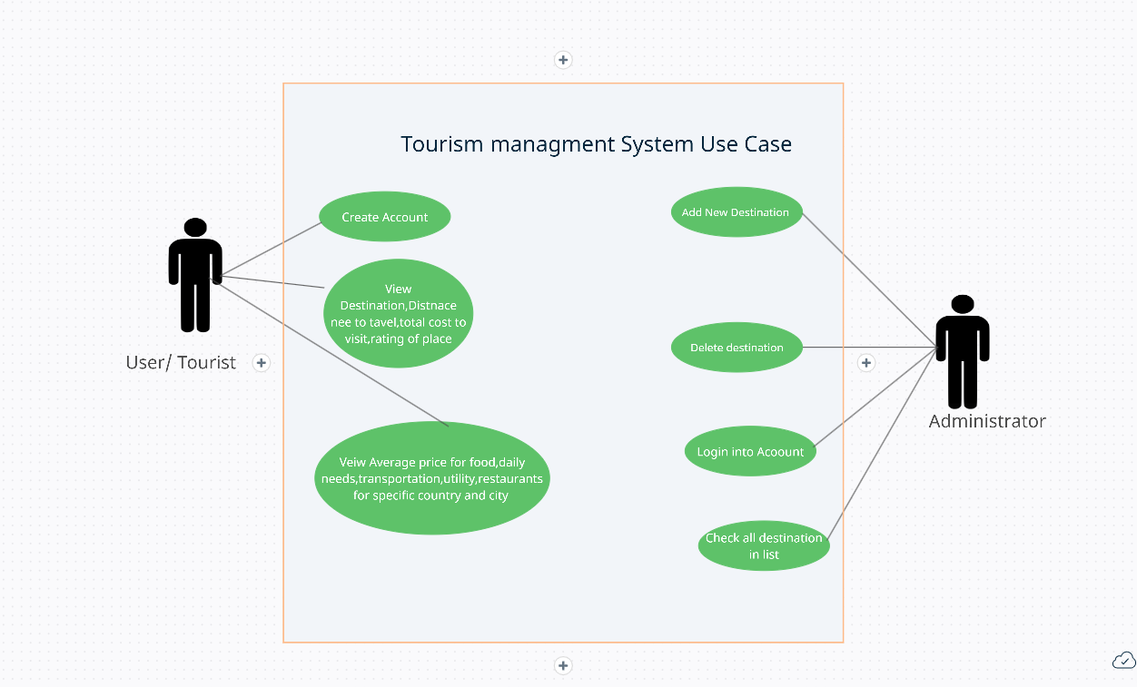

.

Class Diagram
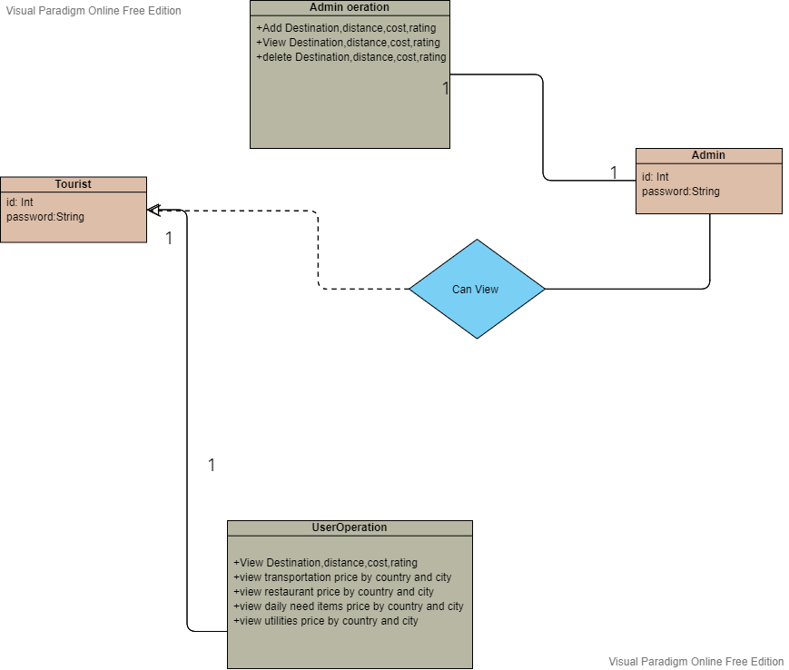

Working of system
The system consist of two actors
- Admin
- Tourist

Role of Admin
- Login
- Add popular destination in Kyoto
- Add data relevant information related to destinations such as Distance from Kyoto station, cost to visit the place and rating of the place.
- Delete the data
- View the data

Role of Tourist
- Login
- View Details of destination
- View restaurant price by country and city
- View utility price by country and city
- View daily needs price by country and city
- View restaurant price by country and city
- Compare the above details with the other country and city

For the admin side operations I have used OpenCSV library to store the information

OpenCSV: Opencsv is an easy-to-use CSV (comma-separated values) parser library for Java. It was developed because all the CSV parsers at the time didn’t have commercial-friendly licenses. Java 8 is currently the minimum supported version.

Operation performed
- Add
- Delete
- View

Read/write operation

/*HERE STARTS REUSED CODE FROM THE URL LINK
Link : http://opencsv.sourceforge.net/#reading_into_an_array_of_strings

//Reading data into array

CSVReader reader = new CSVReader(new FileReader("yourfile.csv"));
List<String[]> myEntries = reader.readAll();

*/
//HERE ENDS REUSED CODE FROM THE URL LINK

Dependencies:
- opencsv-5.6.jar
- commons-lang3-3.1.jar

how to install jar file
go to file →project structure→ look right side for module tab →look for dependencies tab→click + icon→add both dependencies which got downloaded in downloads folder

Tourist side Operation
- View Details of destination – done using openCSV READ Operation
- View restaurant price by country and city
- View utility price by country and city
- View daily needs price by country and city
- View restaurant price by country and city

Operation 1-4 is performed by getting data from RAPIDAPI
RapidAPI : https://rapidapi.com/traveltables/api/cost-of-living-and-prices/
RapidAPI Hub, you can do all this in a few minutes. It is a platform, an API hub that provides access to thousands of usable APIs. The APIs are categorized into 45 different categories, each containing hundreds if not thousands of APIs. It also provides a search feature where you can search for the API you need.

Endpoint Used:
GET Call for PRICES

Dependencies:
- json-simple-1.1.1.jar
- httpmime-4.2.3.jar
- json-20220320
- http-client
- nio
- unirest-java-1.4.7
- httpasyncclient-4.0.2

/*HERE STARTS REUSED CODE FROM THE URL LINK
Link :
- https://rapidapi.com/traveltables/api/cost-of-living-and-prices/
- https://traveltables.com/compare/

getting http response from unirest in java
Unirest: Unirest is a library to simplify making HTTP REST requests. It's open source and available in multiple languages.

HttpResponse<String> response = Unirest.get("https://cost-of-living-and-prices.p.rapidapi.com/prices?city_name=Bratislava&country_name=Slovakia)
.header("X-RapidAPIKey","85d3ffcbc8msh3caab9f2aa2545fp130091jsn6e0ab5b574c0")
.header("X-RapidAPI-Host", "cost-of-living-and-prices.p.rapidapi.com")
.asString();

*/
//HERE ENDS REUSED CODE FROM THE URL LINK

Further the endpoints is tested for various country and cities based on uses input give desired output

Conclusion

In this project I have successfully imprmentend CRUD oeration and done oop methodology.
I have also learn about API integration and working with external dependencies

